
Lab Program Number: 8 Date: 2082-04-25
Title: Creating VLAN and VLAN Trunking using Packet Tracer

Theory
VLAN
A VLAN (Virtual Local Area Network) is a logical partition of a physical network that allows devices to be grouped together based on function, team, or application, regardless of their physical location. VLANs improve efficiency by minimizing unnecessary traffic, as broadcast messages are restricted within the same VLAN.
VLAN-Trunking
VLAN trunking is a technique that enables multiple VLANs to share a single communication link between switches or other network devices. This is done by tagging data frames with VLAN IDs, usually following the IEEE 802.1Q standard. Trunking allows traffic from multiple VLANs to pass through the same connection, reducing cabling needs and increasing network flexibility.
VLAN-Architecture
The architecture of VLANs is designed to provide logical separation of devices while still using a common physical infrastructure. Each VLAN forms its own broadcast domain, ensuring that network congestion and unnecessary communication are reduced. VLANs typically use access ports for connecting end devices and trunk ports for carrying traffic of multiple VLANs across network switches.
Component Used
Hardware: Switches (2), Ethernet cables, End devices (4)
Software: Cisco Packet Tracer

Network Diagram
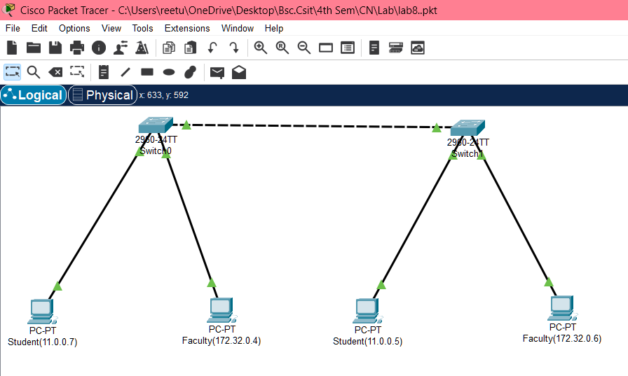
Fig: Network map for VLAN

Procedure
The procedure for creating the LAN network shown in the image using Cisco Packet Tracer:
Step 1: Launch Cisco Packet Tracer
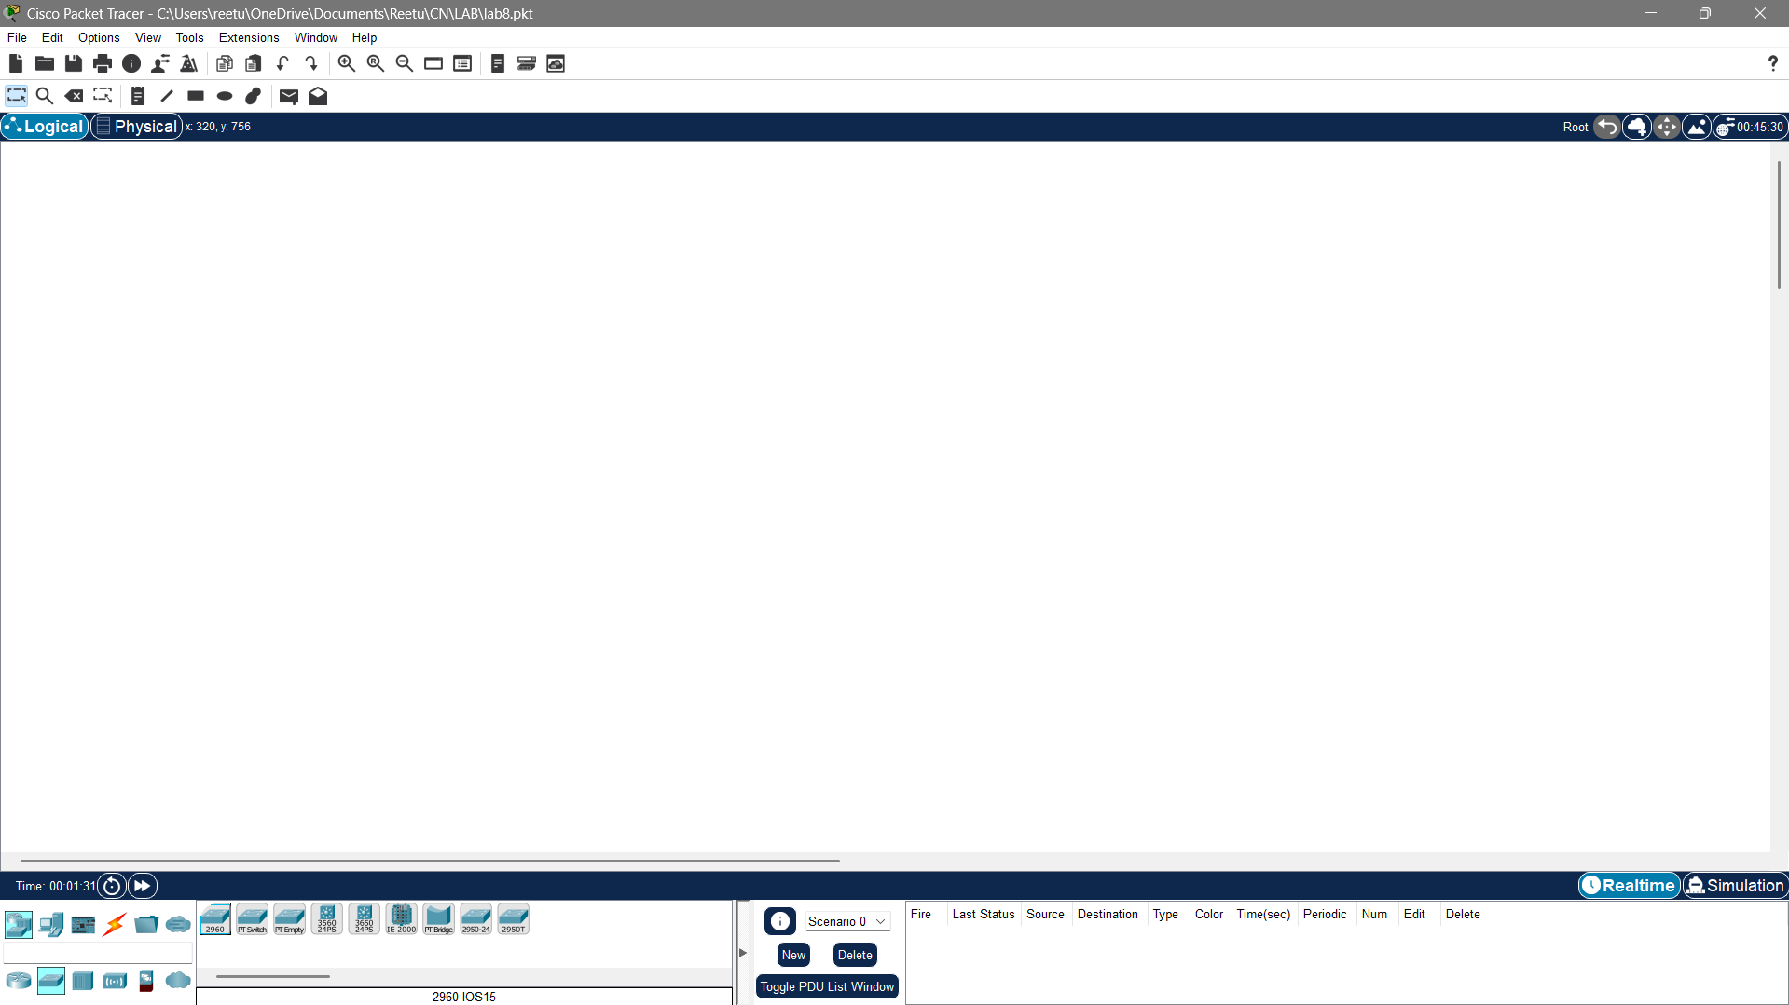
Fig: Workspace for network design
Step 2: Add the network devices to the workspace and connecting devices:

  - From the Device-Type Selection box, choose the following devices and add them to the workspace:
One 2960-24TT Switch and four PC’s
  - Use the copper straight-through cable to connect each PC to one of the available ports on the switch.
  - Ensure that each connection is made properly.
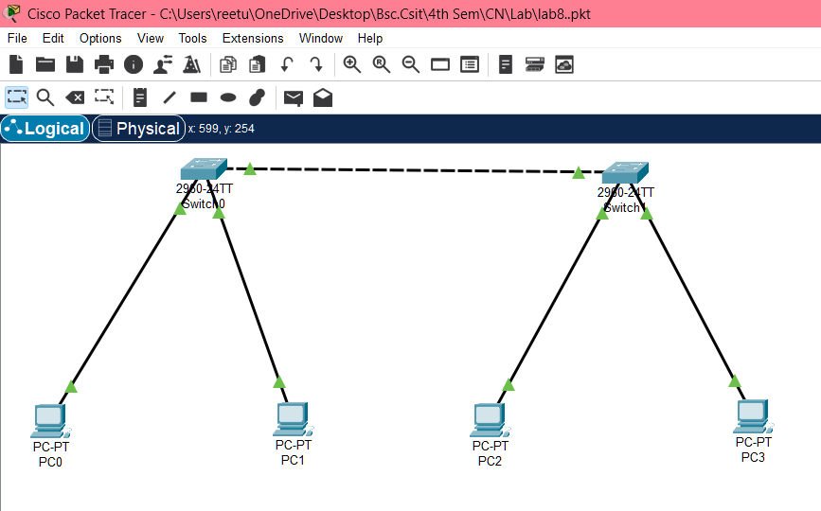
Fig: Connection between all devices in VLAN

Step 3: Configure IP address:

  - Right-click on each PC and select "IP Configuration".
  - In the IP Configuration window, enter the IP address as 19.168.10.9 for port 1 and 19.168.17.19 for port 2 in switch 0 and 19.168.10.8 for port 1 and 19.168.17.17for port 2 in switch 1, subnet mask, and default gateway for each PC.
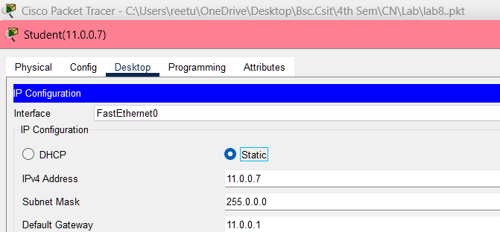
Fig: IP configuration
Step 4: Configuring VLANs:

  - Create VLAN on both Switches & Assign Port to both switches.
Create truncation in both switches.
Code for VLAN configurations:
Switch(config)#vlan 10
Switch(config-vlan)#name student
Switch(config-vlan)#vlan 20
Switch(config-vlan)#name faculty
Switch(config-vlan)#exit
Switch(config)#exit
Code for Assigning ports:
Switch#config t
Switch(config)#int fa 0/1
Switch(config-if)#switchport mode access
Switch(config-if)#switchport access vlan 10
Switch(config-if)#int fa 0/2
Switch(config-if)#switchport mode access
Switch(config-if)#switchport access vlan 20
Switch(config-if)#exit
Switch(config)#exit

Code for Trunking Switches:
Switch#config t
Switch(config)#int fa 0/3
Switch(config-if)#switchport mode trunk
Switch(config-if)#exit
Switch(config)#exit
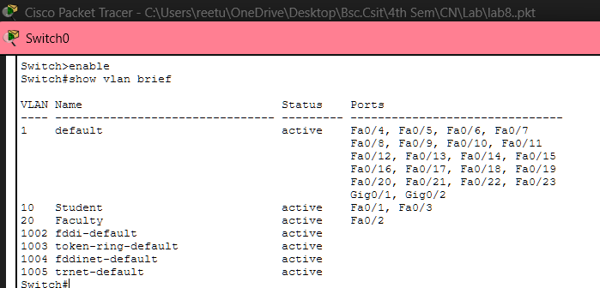
Fig: Assigning ports to VLAN
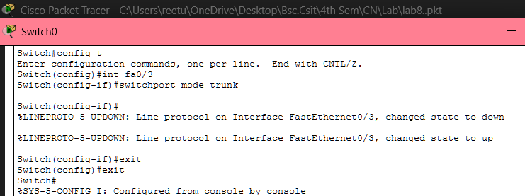
Fig: Configuring trunking between switches

Step 5: Verify connectivity
  - To test whether the network is working, you can ping other devices on the network from each PC.
  - To ping another device, open a command prompt on the PC and type "ping <IP address of the other device>."
  - If the ping is successful, you should see replies from the other device.

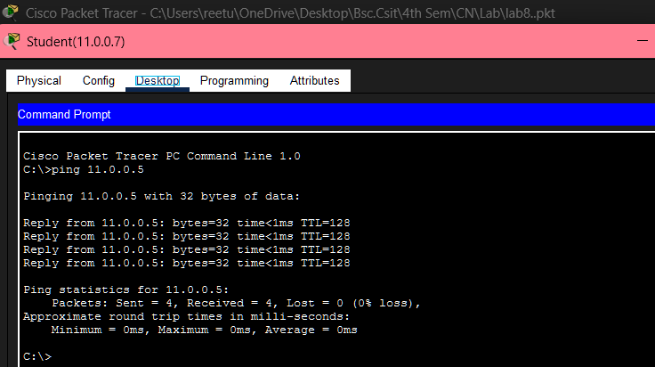
Fig: Connectivity test between network Student (11.0.0.7) and (11.0.0.5)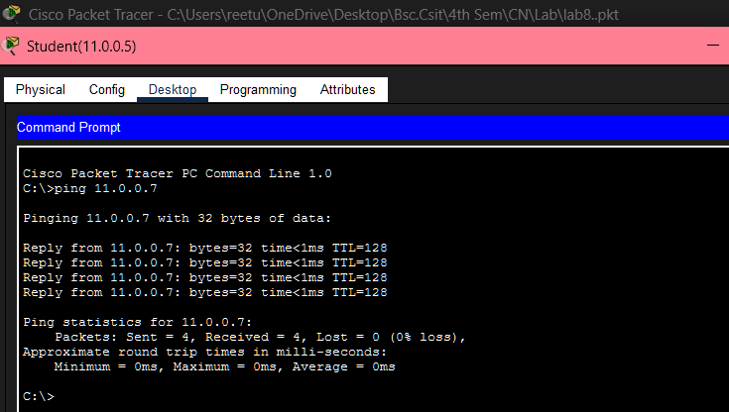
Fig: Connectivity test between network Student (11.0.0.5) and (11.0.0.7)
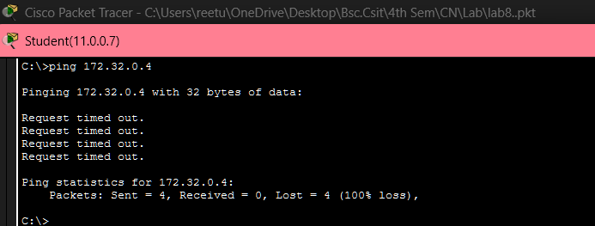
Fig: Connectivity test between network Student (11.0.0.7) and Faculty (172.32.0.4)

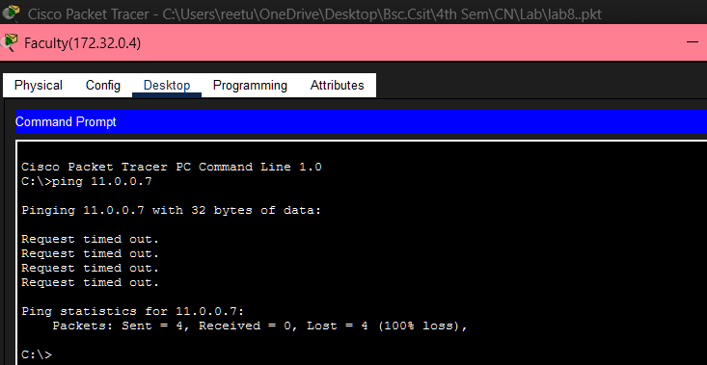
Fig: Connectivity test between network Faculty (172.32.0.4) and Student (11.0.0.7)

Addressing Table
The addressing table of the VLAN is as follows:
Device | Interface | IPv4 Address | Subnet | Switch Port | VLAN No. | VLAN Name | Link
PC0 | NIC | 11.0.0.7 | 255.0.0.0 | Fa0/1 | 10 | Student | Access
PC1 | NIC | 172.32.0.4 | 255.255.0.0 | Fa0/2 | 20 | Faculty | Access
PC2 | NIC | 11.0.0.5 | 255.0.0.0 | Fa0/3 | 10 | Student | Access
PC3 | NIC | 172.32.0.6 | 255.255.0.0 | Fa0/2 | 20 | Faculty | Access

Conclusion
In this lab, we created VLANs and implemented VLAN trunking using Cisco Packet Tracer to enhance network segmentation and management. By assigning devices to specific VLANs, we successfully reduced broadcast domains, improved network security, and optimized performance. VLAN trunking allowed multiple VLANs to communicate efficiently across switches through a single link. This lab demonstrated the importance of structured network design in minimizing broadcast traffic, simplifying network administration, and improving the scalability and efficiency of modern networks.

